06 December 2022

Evening

**SERVICE TEAM HANDS ON -WEEK8 (cheque book upload and acknowledgement)**

**What is the purpose of these hands-on exercises?**

* To enable the end users to put into practice the recently acquired Finacle knowledge in readiness for the final switch over from BFUB, Branch Power and Bank Master to Finacle.
* To increase the proficiency level of Finacle by all end users.
* To ensure that the end user is able to execute all possible permutations of transactions or online processes on Finacle as currently performed on BFUB/Branch Power/Bank Master Day to day.

**How will I access Finacle?**

* URL: <https://drcbssit.co-opbank.co.ke:51500/fininfra/ui/SSOLogin.jsp>
* Select Core_CBKSIT solution

**What is expected of me?**

* Ensure all exercises are completed.
* Raise any challenges with the CBI team immediately they are encountered for support.
* Be committed to complete these exercises on time and share feedback.

**What happens when I complete the exercises?**

* Fill back the returns through the team leader after completion of the exercises
* Repeat the exercises as much as possible.
* Help your colleagues in the branch/department who may be stuck.

**Exercise Objectives**

1. Running of batch job MBJST, VBJST and BEJ
2. Cheque book upload CUCBD
3. Cheque book issuance to customer
4. Verification of cheque book issuance

# Batch job amendment MBJST

1. Invoke MBJST menu
2. Under Job Id type CHQDW
3. Click on search
4. Select on CHQDW and click continue
5. Click on edit button and change date to BOD date
6. Click on update then click submit
7. Transaction will proceed to verification

# Verify Batch job VBJST

1. Verifier to invoke menu VBJST
2. Under Job Id type CHQDW
3. Click on search
4. Select record displayed and view details
5. Submit to verify

# Running batch job BEJ

1. Invoke menu BEJ
2. Under From Job Id and To Job ID type CHQDW
3. Submit the batch job

# Cheque book upload CUCBD

1. Prepare a notepad file containing a list of cheque books which have been received at the branch. For example,

01100002828023|1|!|100|U

**0110002828023 ---Account number**

**1 ---Represent begin cheque number**

**! ---begin alpha**

**100 ---Number of leaves**

**U ---stands for undelivered**

1. Enter more than one record e.g., and save it on desktop

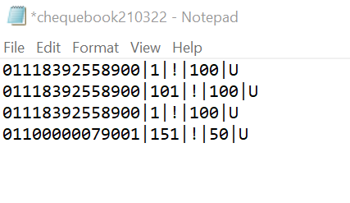

1. Invoke menu CUCBD
2. Chose the notepad file saved
3. Upload the file
4. Click on submit button
5. Invoke menu **ICB** to inquire the status of cheque book, under issued but not acknowledged field, it should contain the number cheque leaves requested.

# Cheque book acknowledgement

1. Invoke menu **ACB**
2. Enter account number with a cheque book which is not issued
3. View details then submit for verification

# Verify cheque book acknowledgement

1. Invoke menu **VCBA**
2. Enter account number or search for pending records
3. View details
4. Submit to verify transaction.